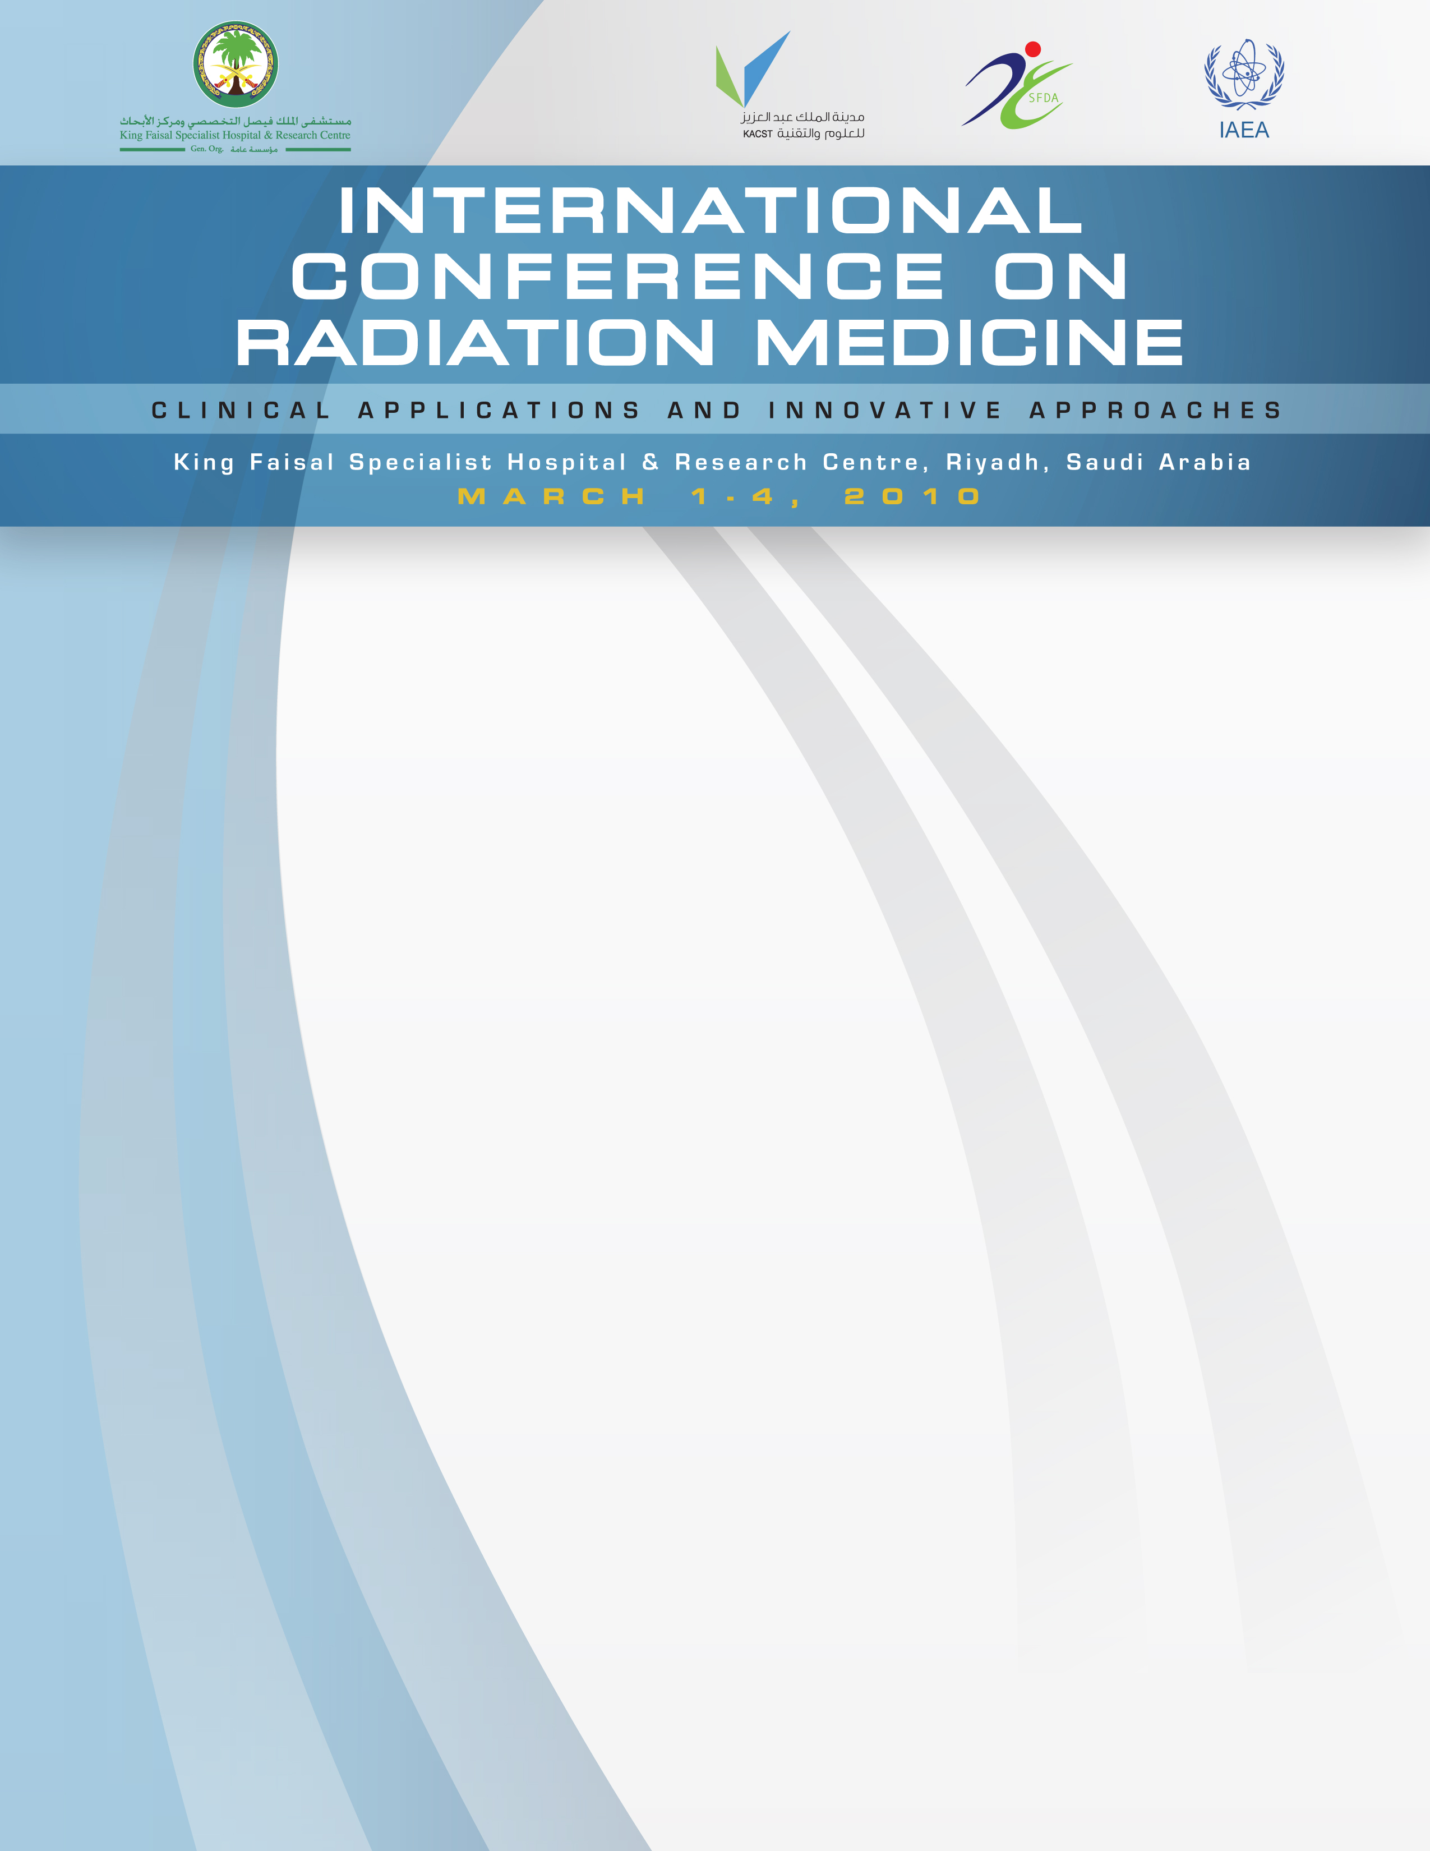

READING OF THE HOLY QURAN:

OPENING REMARKS:

IAEA Director Address:

chief executivE director Address:

Dr. Mohammed Samman
Scientist,
Research Centre, KFSH&RC

Dr. Belal Moftah
Director, IAEA Course
Chairman, ICRM 2010 Organizing Committee
Chairman, Biomedical Physics Department
Research Centre, KFSH&RC

Dr. Donald Mclean
International Atomic Energy Agency
Austria

HE Dr. Qasim Al-Qasabi
Chief Executive Director,
King Faisal Specialist Hospital & Research Centre

OPENING CEREMONY PROGRAM
Sunday, February 28, 2010
Prince Salman Auditorium, KFSH&RC
10:00 AM



